**Experiment No. 10**

Name: Trupti Pandhare ID. No.: VU4s2223010

Batch: C ­­­Div: B

**Aim**: - Detailed case study of any one BI tool such as Pentaho, Tableau and QlikView.

**Theory :**  As the market-leading choice for modern business intelligence, our analytics platform makes it easier for people to explore and manage data, and faster to discover and share insights that can change businesses and the world. Everything we do is driven by our mission to help people see and understand data, which is why our products are designed to put the user first—whether they’re an analyst, data scientist, student, teacher, executive, or business user. From connection through collaboration, Tableau is the most powerful, secure, and flexible end-to-end analytics platform. Tableau disrupted business intelligence with intuitive, visual analytics for everyone Tableau was founded in 2003 as a result of a computer science project at Stanford that aimed to improve the flow of analysis and make data more accessible to people through visualization. Co-founders Chris Stolte, Pat Hanrahan, and Christian Chabot developed and patented Tableau's foundational technology, VizQL—which visually expresses data by translating drag-and-drop actions into data queries through an intuitive interface. Since our foundation, we’ve continuously invested in research and development at an unrivalled pace, developing solution to help anyone working with data to get to answers faster and uncover unanticipated insights. This includes making machine learning, statistics, natural language, and smart data prep more useful to augment human creativity in analysis. And we not only offer a complete, integrated analytics platform, but also proven enablement resources to help customers deploy and scale a data-driven culture that drives resilience and value through powerful outcomes. Tableau was acquired by Sales force in 2019, and our mission remains the same: to help people see and understand their data. Today, organizations everywhere—from non-profits to global enterprises, and across all industries and departments—are empowering their people with Tableau to drive change with data. Tableau Uses: Usage of Tableau software is listed below: Business Intelligence Data Visualization Data Blending Data Collaboration Query translation into visualization To create no-code data queries Real-time data analysis To manage large size metadata To import large size of data Ever since it was introduced, this data visualization tool is used for the Business Intelligence industry. Organizations like Amazon, Wal-Mart, Accenture, Lenovo, and so on widely use Tableau. Join Tableau training in London and excel in your career!

Why Tableau? Why use Tableau software when there are a whole lot of tools available to perform data visualization?

Tableau is greatly used because data can be analysed very quickly with it. Also, visualizations are generated as dashboards and worksheets. Tableau allows one to create dashboards that provide actionable insights and drive the business forward. Tableau products always operate in virtualized environments when they are configured with the proper underlying operating system and hardware. Tableau is used by data scientists to explore data with limitless visual analytics. ETL Refresh and many more make Tableau one of the most famous Data Visualization tools. Go through the Tableau Course in New York to get a clear understanding of benefits of using Tableau. What is Data Visualization in Tableau? Data Visualization is a pictorial representation of a dataset or information using maps, graphs, charts, and other visual elements. Data Visualization helps in easy understanding of the trend, insights, patterns, and other connections in a Dataset. Tableau is one of the most popular Data Visualization tools used by many enterprises and businesses to gain better insights into their data to offer the best customer experience. How does Tableau work? The major work of Tableau software is to connect and extract the data stored in various places. It can pull data from any platform. Tableau can extract data from any database, be it Excel, PDF, Oracle, or even Amazon Web Services. Once Tableau is launched, ready data connectors are available which allow you to connect to any database. The data extracted can be connected live to the Tableau data engine, Tableau Desktop. This is where a Data Analyst or a Data Engineer works with the data that was pulled up and develop visualization. The created dashboards are shared with users in the form of static files. The users receiving dashboards view the files using Tableau Reader. The data extracted from Tableau Desktop can be published to Tableau Server, which is an enterprise platform where collaboration, distribution, governance, security model, and automation features are supported. Using Tableau Server, end users can access the files from all locations, be it a desktop or a mobile phone. As it can be seen in the image below, Tableau Business Intelligence and Data Visualization tool has been placed in the Leader’s quadrant for seven consecutive years in the Business Intelligence and Analytics platforms by the IT research firm, Gartner. How Does Tableau Work Gartner Magic Quadrant for Business Intelligence and Analytics Platforms Following are the two ways in which Data Analytics of Tableau can be described: Developer Tools: Tools used in development, like designing charts, dashboards, reports, and visualizations, come under this category. The major Tableau products in this category are Tableau Public and Tableau Desktop. Sharing Tools: By the name, you would have understood what these tools do. Well, they are used for sharing reports, visualizations, and dashboards which are created using the developer tools. The main products that fall in this category are Tableau Online, Tableau Reader, and Tableau Server.

Tableau Product Suite Tableau Product Suite includes Tableau Server, Tableau Desktop, Tableau Reader, and so on. Let’s understand what exactly is meant by these terms in the following sections: This product allows one to code and modifies the reports. Starting from creating reports and charts to combining them to form a dashboard, all this work is done in Tableau Desktop. Tableau Desktop is classified into the following according to connectivity and data sources: Tableau Desktop Personal The development features of the Tableau Desktop Personal version are close enough to that of the Tableau Desktop. In this particular version, the workbook is in private mode and the access is limited. That means, these workbooks can’t be posted and are for personal use only. Therefore, they have to be divided either on Tableau Public or Offline. Tableau Desktop Professional This version is very much like Tableau Desktop, only that the work generated or created in Tableau Desktop is published on the Tableau Server. In this version, there would be full access to all sorts of data types. It is great for people who wish to publish their work on the Tableau Server. What is Tableau Reader? It is a tool that allows one to view visualizations and workbooks generated using Tableau Public or Tableau Desktop. This data can easily be filtered, yet modifications are limited. Since anyone getting the workbook can view it using Tableau Reader, there is no security. What is Tableau Server? This is mainly used to share visualizations and workbooks which get generated in the Tableau Desktop application throughout the organization. The work will become accessible once it is uploaded to the respective servers. To increase sharing of dashboards in Tableau Server, you should publish your work beforehand in Tableau Desktop. Though, it’s not completely mandatory for licensed users to have an installed Tableau Server. They just need the login credentials using which they can verify these reports. As the security of Tableau Server is high, it is convenient for fast and effective data sharing in the organization. If you have any doubts or Queries related to Tableau, get them clarified by BI Experts in BI Community. Go through our blog on what is Tableau Server to learn in detail. Tableau Online As the term ‘online’ suggests, Tableau Online is a sharing tool. It has a similar usage as Tableau Server, but the data is saved on servers that are provided in the cloud maintained by the Tableau group. The data that can be published on Tableau Online has no storage limit. Tableau Online and Server, both need workbooks that are created by Tableau Desktop to broadcast the data. Data streamed from web applications, be it Sales force or Google Analytics, are supported by both, Tableau Online and Tableau Server. Tableau Public Tableau Public is specially built for money-saving users. As the word ‘public’ suggests, the created workbooks can’t be locally saved, rather it is sent to Tableau’s public cloud which can be accessed by the general public. This is an economical version which is very good for people wanting to learn and share their data with people.

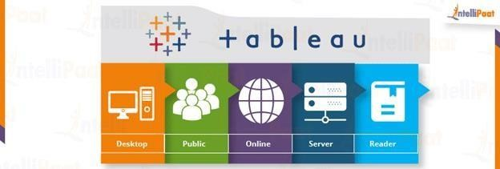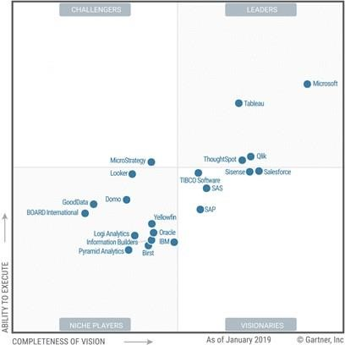

Hence we can refer the above figures for more in-depth and clear observation about Tableau use

**Conclusion:-** Successfully Researched on case study of BI tool such as Tableau.